**Name(s): _ _ _ ___ _ Date:_ _ _ Period:_ _**

**Electric Field Shapes Lab**

**Required Materials:**

* Conducting Paper and Conducting Pen OR pre-made electrodes
* Circle Stencil
* Cork boards
* Pins / thumbtacks
* Multimeter (set to 2 in the Volt (V) section)
* Battery (12 V)
* Wires
* Graphing Paper (Provided on page 4)

**Purpose:** To determine the shape of an electric field with various electrode configurations by finding the equipotential lines.

**Theory:** Equipotential lines are lines that have the same voltage (the potential difference between any two points on the line is the same). These lines are significant in Physics because no work is required to move a charged particle or other object along equipotential lines. In relation to electric fields, equipotential lines are *always* perpendicular to the electric field lines. By finding these equipotential lines, the electric field can be drawn. Two examples are shown below, with the solid lines representing the electric field lines, and the dashed lines representing the equipotential lines.

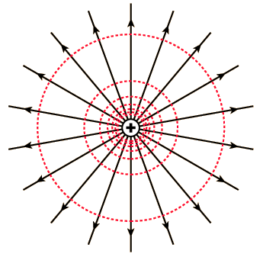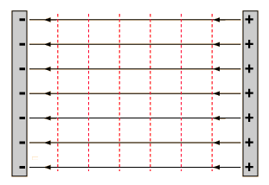

**Procedure (if pre-drawn electrodes are being used, hand out the electrodes and skip to step 3):**

1. Examine the electrode diagrams on page 3. Decide what configurations you are going to draw.
2. Using the conductive paper and conductive pen, draw the decided configurations. If the electrode involves a circle, use the circle stencil. Then, let the electrode dry for about 15 minutes.
3. Put the electrode on a cork board, and then place a pin on each side of the electrode. Leave enough exposed metal from the pins, as the battery will be connected to them.

Use Diagram 1 below as an illustration of the completed set-up.

1. Connect a wire to each of the pins (on the metal of the pin) and then connect the other end of each wire to the 12V battery.
2. Place the Common Line of the multimeter (wire denoted by COM on the multimeter) on one of the pins on the electrode.
3. Use the other pin of the multimeter and drag it around the electrode. Find equipotential lines by moving the pin and not having the voltage change.
4. Graph the lines on a piece of graph paper. Use the graphing paper on page 4.
5. When finished, complete the conclusion questions below on a separate piece of paper.

**Conclusion Questions:**

1. What is the equation for work with respect to charge? Does it support the idea that no work is done because voltage is constant? Explain. Also, if no work is done, does this mean a force is not exerted?
2. Why did the electric field differ for each electrode configuration? Why do curved plates change the electric field in comparison to parallel plates?
3. Can two equipotential lines cross each other? Explain.
4. If an electron is placed inside an electric field, will it move towards higher or lower potential? What if a positive charge is used? On one of the equipotential line graphs, briefly describe the motion of an electron placed at the center of the electric field.
5. 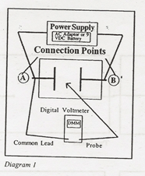If a dielectric is used in an electric field, what is the effect of the electric field distribution?

**Diagrams:**

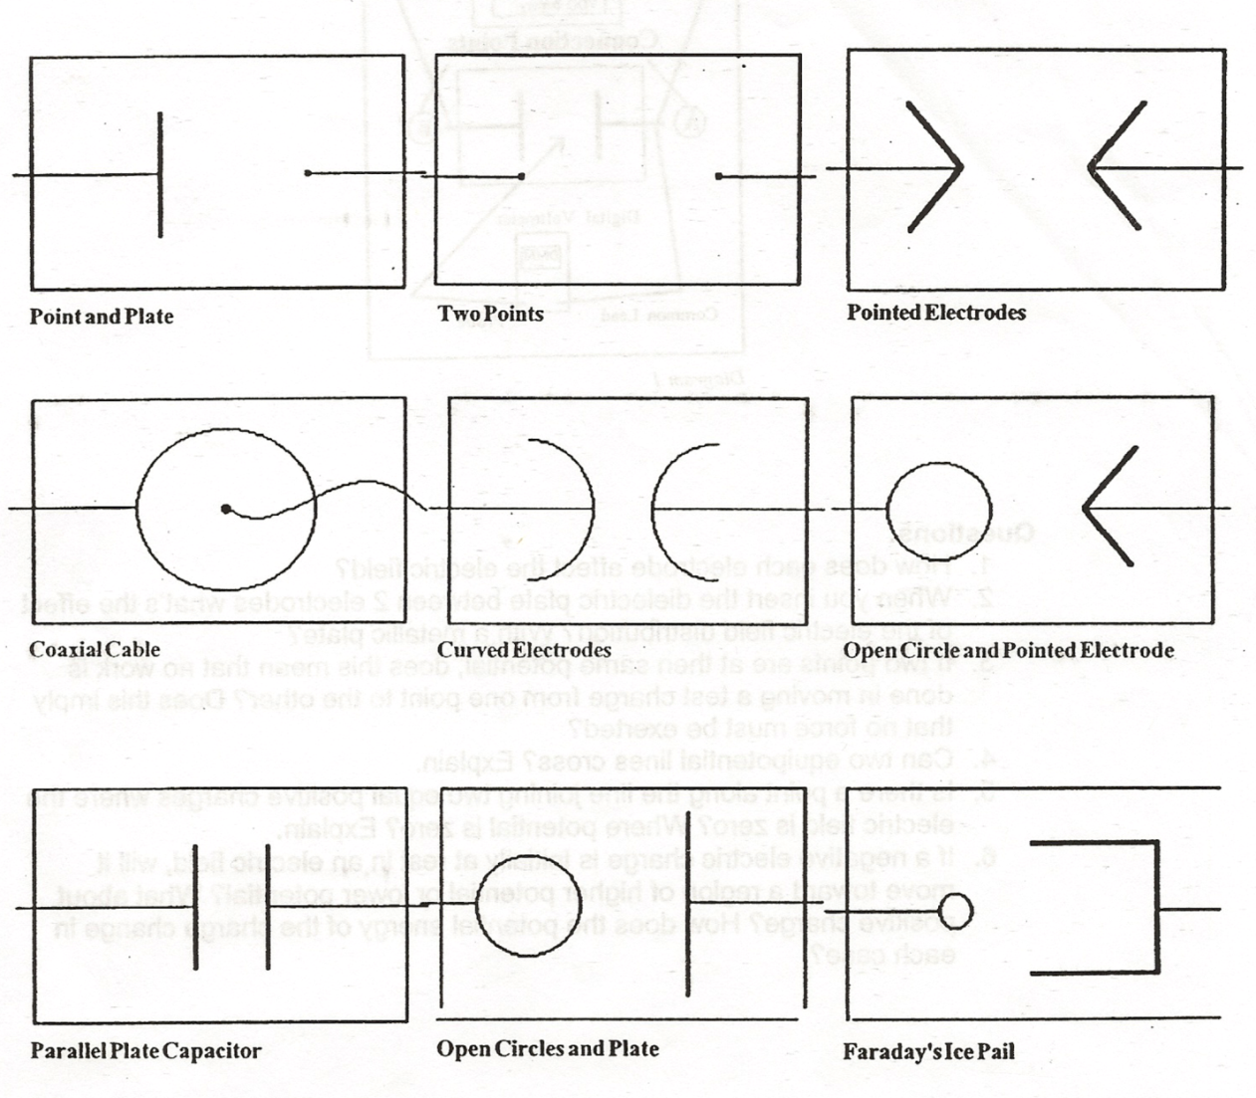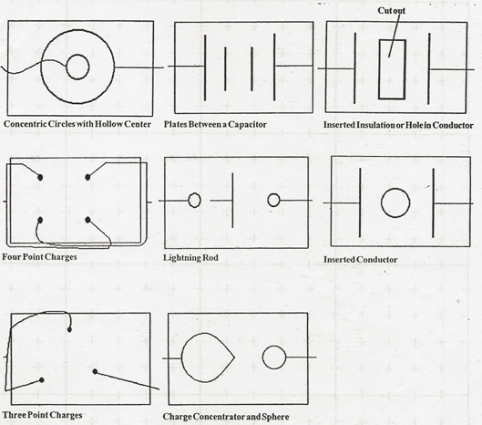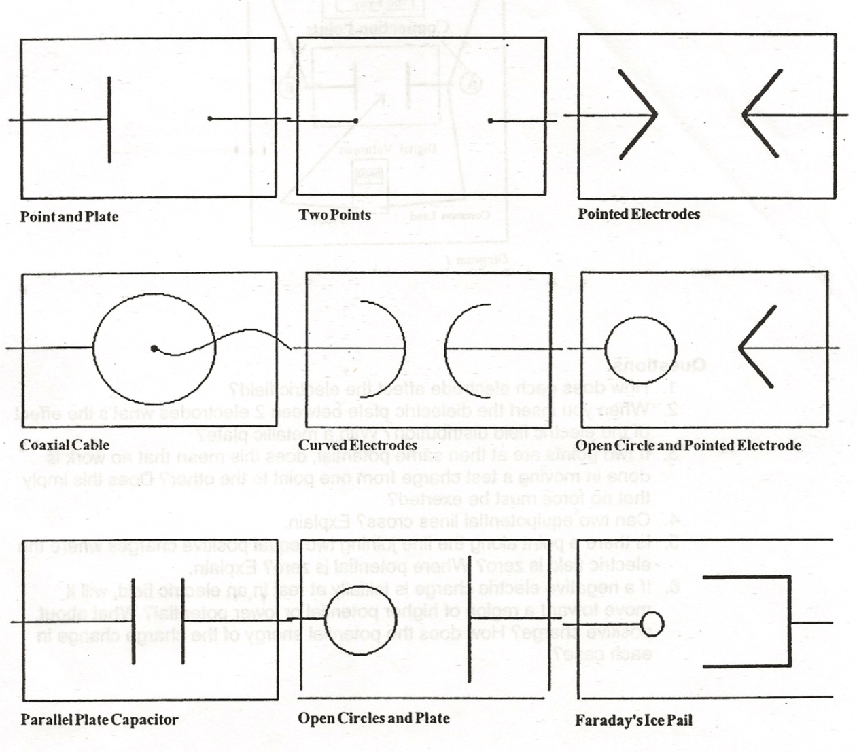

Cut out

